SECTION 1: IDENTIFICATION

1.1. Product Identifier
Product Form: Mixture
Product Name: Nelson Aerosol – Wet Rock
Product Code: 6141/AA1E, 6147/AA1I, 7144/AA1H
Synonyms: Mine Marker

1.2. Intended Use of the Product
Paint

1.3. Name, Address, and Telephone of the Responsible Party

Manufacturer

The Nelson Paint Company of Canada
48 Industrial Park Crescent
Sault Ste Marie Ontario, Canada
P6B 5P2
705-759-4680

1.4. Emergency Telephone Number
Emergency Number | : | In US and Canada CHEMTEL: 1-800-255-3924 or Canutec 613-996-6666

SECTION 2: HAZARDS IDENTIFICATION

2.1. Classification of the Substance or Mixture

GHS-CA Classification
This material is considered hazardous under Canadian WHMIS 2015 Regulations.

Simple Asphy
Flam. Aerosol 1 | H222
Press. Gas (Comp.) | H280
Skin Irrit. 2 | H315
Eye Irrit. 2A | H319
Skin Sens. 1 | H317
Muta. 1 | H340
Carc. 1 | H350
Repr. 2 | H361
STOT SE 3 | H336
Aquatic Acute 3 | H402
Aquatic Chronic 3 | H412

Full text of hazard classes and H-statements : see section 16

2.2. Label Elements

GHS-CA Labeling
Hazard Pictograms (GHS-CA) | : | 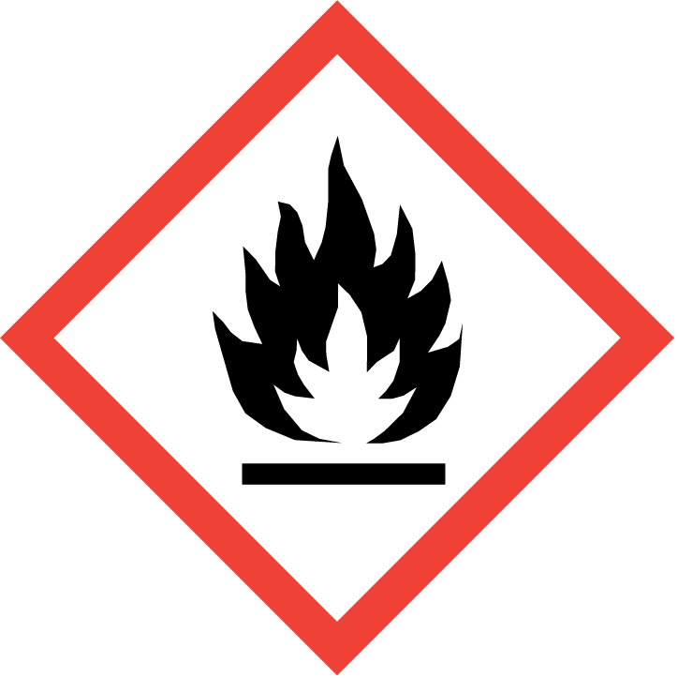  GHS02 | 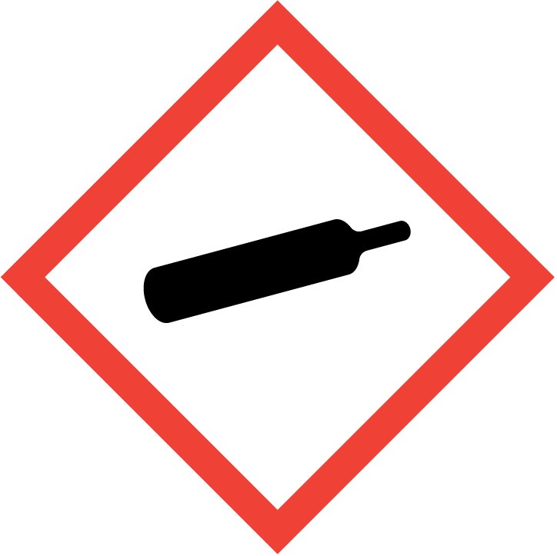  GHS04 | 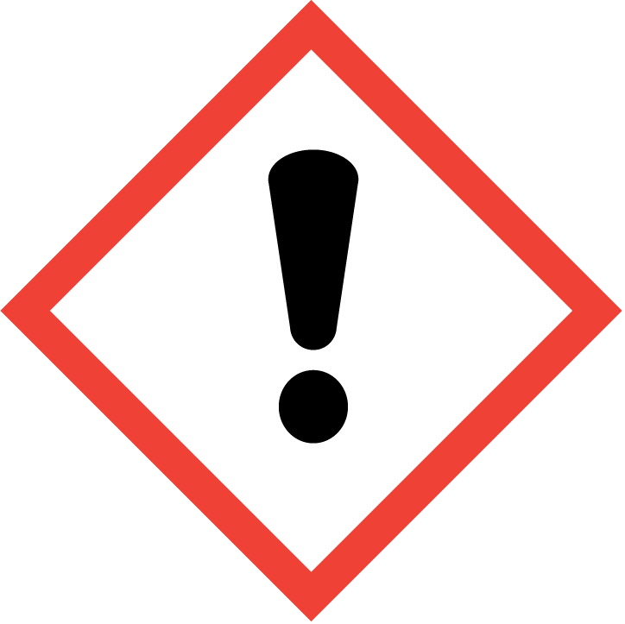  GHS07 | 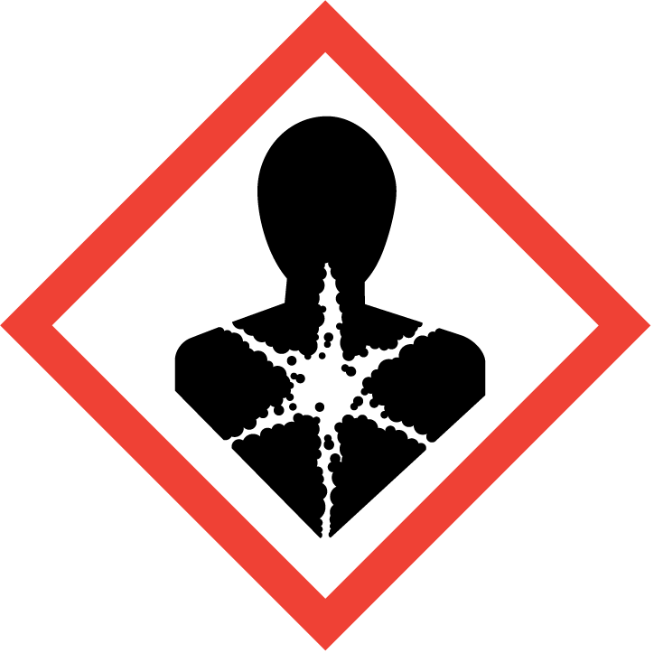  GHS08
Signal Word (GHS-CA) | : | Danger
Hazard Statements (GHS-CA) | : | H222 - Extremely flammable aerosol.  H280 - Contains gas under pressure; may explode if heated.  H315 - Causes skin irritation.  H317 - May cause an allergic skin reaction.  H319 - Causes serious eye irritation.  H336 - May cause drowsiness or dizziness.  H340 - May cause genetic defects.  H350 - May cause cancer.  H361 - Suspected of damaging fertility or the unborn child.  H402 - Harmful to aquatic life.  H412 - Harmful to aquatic life with long lasting effects.  May displace oxygen and cause rapid suffocation.
Precautionary Statements (GHS-CA) | : | P201 - Obtain special instructions before use.  P202 - Do not handle until all safety precautions have been read and understood.  P210 - Keep away from heat, hot surfaces, sparks, open flames and other ignition sources. No smoking.  P211 - Do not spray on an open flame or other ignition source.  P251 - Do not pierce or burn, even after use.  P261 - Avoid breathing gas, vapors, mist, or spray.  P264 - Wash hands, forearms, and other exposed areas thoroughly after handling.  P271 - Use only outdoors or in a well-ventilated area.  P272 - Contaminated work clothing should not be allowed out of the workplace.  P273 - Avoid release to the environment.  P280 - Wear protective gloves, protective clothing, and eye protection.  P302+P352 - IF ON SKIN: Wash with plenty of water.  P304+P340 - IF INHALED: Remove person to fresh air and keep comfortable for breathing.  P305+P351+P338 - IF IN EYES: Rinse cautiously with water for several minutes. Remove contact lenses, if present and easy to do. Continue rinsing.  P308+P313 - If exposed or concerned: Get medical advice/attention.  P312 - Call a POISON CENTER or doctor if you feel unwell.  P321 - Specific treatment (see section 4 on this SDS).  P333+P313 - If skin irritation or rash occurs: Get medical advice/attention.  P337+P313 - If eye irritation persists: Get medical advice/attention.  P362+P364 - Take off contaminated clothing and wash it before reuse.  P403+P233 - Store in a well-ventilated place. Keep container tightly closed.  P405 - Store locked up.  P410+P412 - Protect from sunlight. Do not expose to temperatures exceeding 50 °C/122 °F.  P501 - Dispose of contents/container in accordance with local, regional, national, and international regulations.

2.3. Other Hazards
Exposure may aggravate pre-existing eye, skin, or respiratory conditions. Contact with gas escaping the container can cause frostbite.

2.4. Unknown Acute Toxicity (GHS-CA) Not available
SECTION 3: COMPOSITION/INFORMATION ON INGREDIENTS

3.1. Substance
Not applicable

3.2. Mixture
Name | Product Identifier | % * | GHS Ingredient Classification
Acetone | (CAS-No.) 67-64-1 | 22.66 - 22.9592 | Flam. Liq. 2, H225  Eye Irrit. 2A, H319  STOT SE 3, H336
Petroleum gases, liquefied, sweetened | (CAS-No.) 68476-86-8 | 22.56 | Flam. Gas 1, H220  Press. Gas (Comp.), H280
Propane | (CAS-No.) 74-98-6 | 22.01856 | Simple Asphy  Flam. Gas 1, H220  Press. Gas (Liq.), H280
Limestone | (CAS-No.) 1317-65-3 | 14.7946 - 18.4712 | Not classified
Naphtha, petroleum, hydrotreated light | (CAS-No.) 64742-49-0 | 12.4642 - 14.1519 | Flam. Liq. 1, H224  Skin Irrit. 2, H315  Muta. 1B, H340  Carc. 1B, H350  Repr. 2, H361  STOT SE 3, H336  Asp. Tox. 1, H304  Aquatic Acute 2, H401  Aquatic Chronic 2, H411
Titanium dioxide | (CAS-No.) 13463-67-7 | 0.54912 - 12.3927 | Carc. 2, H351
Chlorinated paraffin waxes and hydrocarbon waxes | (CAS-No.) 63449-39-8 | 7.0752 - 7.9816 | Carc. 2, H351
Petroleum distillates, hydrotreated light† | (CAS-No.) 64742-47-8 | <= 2.5784 | Flam. Liq. 3, H226  Skin Irrit. 2, H315  STOT SE 3, H336  Asp. Tox. 1, H304  Aquatic Acute 2, H401  Aquatic Chronic 2, H411
Silica, amorphous | (CAS-No.) 7631-86-9 | <= 1.391016 | Not classified
Naphtha, petroleum, hydrotreated heavy | (CAS-No.) 64742-48-9 | 0.47274 - 0.64997 | Flam. Liq. 3, H226  Skin Irrit. 2, H315  Repr. 2, H361  STOT SE 3, H336  Asp. Tox. 1, H304  Aquatic Chronic 2, H411
Isobutane | (CAS-No.) 75-28-5 | 0.54144 | Simple Asphy  Flam. Gas 1, H220  Press. Gas (Liq.), H280
2-Butanone, oxime | (CAS-No.) 96-29-7 | 0.4048 - 0.4576 | Flam. Liq. 4, H227  Acute Tox. 4 (Dermal), H312  Eye Dam. 1, H318  Skin Sens. 1, H317  Carc. 2, H351  Aquatic Acute 3, H402
Xylenes (o-, m-, p- isomers) | (CAS-No.) 1330-20-7 | 0.37924 - 0.43058 | Flam. Liq. 3, H226  Acute Tox. 4 (Dermal), H312  Acute Tox. 4 (Inhalation:vapor), H332  Skin Irrit. 2, H315  STOT SE 3, H336  STOT SE 3, H335  Asp. Tox. 1, H304  Aquatic Acute 2, H401
Quartz | (CAS-No.) 14808-60-7 | 0.19726 - 0.26020 | Carc. 1A, H350  STOT SE 3, H335  STOT RE 1, H372
Zirconium ethyl hexoate | (CAS-No.) 22464-99-9 | 0.17846 - 0.2501 | Repr. 2, H361
Hexanoic acid, 2-ethyl-, cobalt(2+) salt (2:1) | (CAS-No.) 136-52-7 | 0.12672 - 0.16632 | Acute Tox. 4 (Oral), H302  Eye Irrit. 2A, H319  Skin Sens. 1A, H317  Repr. 2, H361  Aquatic Acute 1, H400  Aquatic Chronic 3, H412
Ethylbenzene | (CAS-No.) 100-41-4 | 0.10113 - 0.11482 | Flam. Liq. 2, H225  Acute Tox. 4 (Inhalation:vapor), H332  Carc. 2, H351  STOT RE 2, H373  Asp. Tox. 1, H304  Aquatic Acute 2, H401  Aquatic Chronic 3, H412
Propylene glycol monomethyl ether | (CAS-No.) 107-98-2 | 0.01478 - 0.04224 | Flam. Liq. 3, H226  STOT SE 3, H336
Full text of H-phrases: see section 16
*Percentages are listed in weight by weight percentage (w/w%) for liquid and solid ingredients. Gas ingredients are listed in volume by volume percentage (v/v%).

Components accompanied by a symbol in this document are not present in all color variations of the product. The health and safety information associated with these components are only applicable to the color variations specified in the legend below.

† Petroleum distillates, hydrotreated light (CAS-No. 64742-47-8) is only present in the yellow and red variations of the product.

SECTION 4: FIRST AID MEASURES

4.1. Description of First-aid Measures
General: Never give anything by mouth to an unconscious person. If you feel unwell, seek medical advice (show the label where possible).
Inhalation: First, take proper precautions to ensure your own safety before attempting rescue (e.g. wear appropriate respiratory protective equipment, use the buddy system), then remove the exposed person to fresh air. Keep at rest in a position comfortable for breathing. Obtain medical attention if breathing difficulty persists.
Skin Contact: Immediately remove contaminated clothing. Immediately drench affected area with water for at least 15 minutes. If exposed or concerned: Get medical advice/attention. Obtain medical attention if irritation/rash develops or persists. For brief contact with a small amount: Rewarm with body heat. Get immediate medical advice/attention. For extensive contact or a large amount: Immediately call a poison center/doctor and follow their advice. Specific treatment is urgent, incorrect first-aid practices will aggravate the injury. Protect affected area with a loose cover until proper medical treatment is received.
Eye Contact: Immediately rinse with water for at least 15 minutes. Remove contact lenses, if present and easy to do. Continue rinsing. Obtain medical attention.
Ingestion: Rinse mouth. Do NOT induce vomiting. Obtain medical attention.

4.2. Most Important Symptoms and Effects Both Acute and Delayed
General: Asphyxia by lack of oxygen: risk of death. Causes skin irritation. Causes serious eye irritation. Skin sensitization. May cause drowsiness and dizziness. May cause cancer. May cause genetic defects. Suspected of damaging fertility or the unborn child. Contact with gas escaping the container can cause frostbite.
Inhalation: High concentrations may cause central nervous system depression such as dizziness, vomiting, numbness, drowsiness, headache, and similar narcotic symptoms. In elevated concentrations may cause asphyxiation, central nervous system effects, and increased breathing rate. Symptoms of asphyxiation include headache, dizziness, rapid breathing, increased pulse, mood changes, tremors, cyanosis, muscular weakness, narcosis, numbness of the extremities, unconsciousness and death.
Skin Contact: Contact with gas escaping the container can cause frostbite and freeze burns. Redness, pain, swelling, itching, burning, dryness, and dermatitis. May cause an allergic skin reaction.
Eye Contact: Contact causes severe irritation with redness and swelling of the conjunctiva. . Contact with gas escaping the container can cause frostbite, freeze burns, and permanent eye damage.
Ingestion: Not considered a potential route of exposure, but contact with gas escaping the container can cause freeze burns and frostbite.
Chronic Symptoms: May cause cancer. May cause genetic defects. Suspected of damaging fertility or the unborn child.

4.3. Indication of Any Immediate Medical Attention and Special Treatment Needed
If exposed or concerned, get medical advice and attention. If medical advice is needed, have product container or label at hand.
SECTION 5: FIRE-FIGHTING MEASURES

5.1. Extinguishing Media
Suitable Extinguishing Media: Water spray, fog, carbon dioxide (CO₂), alcohol-resistant foam, dry chemical, or sand.
Unsuitable Extinguishing Media: Do not use a heavy water stream. Use of heavy stream of water may spread fire.

5.2. Special Hazards Arising From the Substance or Mixture
Fire Hazard: Flammable aerosol.
Explosion Hazard: Heat may build pressure, rupturing closed containers, spreading fire and increasing risk of burns and injuries. Container may explode in heat of fire.
Reactivity: Reacts violently with strong oxidizers. Increased risk of fire or explosion.

5.3. Advice for Firefighters
Precautionary Measures Fire: Exercise caution when fighting any chemical fire.
Firefighting Instructions: Use water spray or fog for cooling exposed containers. Fight fire remotely due to the risk of explosion. DO NOT fight fire when fire reaches containers. Evacuate area.
Protection During Firefighting: Do not enter fire area without proper protective equipment, including respiratory protection.
Hazardous Combustion Products: Carbon oxides (CO, CO₂). Nitrogen oxides. Ammonia. Hydrocarbons.
Other Information: Do not allow run-off from fire fighting to enter drains or water courses.

Reference to Other Sections
Refer to Section 9 for flammability properties.

SECTION 6: ACCIDENTAL RELEASE MEASURES

6.1. Personal Precautions, Protective Equipment and Emergency Procedures
General Measures: Do not breathe gas. Do not breathe vapors, mist, or spray. Do not get in eyes, on skin, or on clothing. Do not handle until all safety precautions have been read and understood. Keep away from heat, hot surfaces, sparks, open flames, and other ignition sources. No smoking.

6.1.1. For Non-Emergency Personnel
Protective Equipment: Use appropriate personal protective equipment (PPE).
Emergency Procedures: Evacuate unnecessary personnel. Stop leak if safe to do so.
6.1.2. For Emergency Personnel
Protective Equipment: Equip cleanup crew with proper protection.
Emergency Procedures: Upon arrival at the scene, a first responder is expected to recognize the presence of dangerous goods, protect oneself and the public, secure the area, and call for the assistance of trained personnel as soon as conditions permit. Evacuate unnecessary personnel, isolate, and ventilate area. Eliminate ignition sources.

6.2. Environmental Precautions
Prevent entry to sewers and public waters. Avoid release to the environment.

6.3. Methods and Materials for Containment and Cleaning Up
For Containment: Stop leak, if possible without risk. As an immediate precautionary measure, isolate spill or leak area in all directions.
Methods for Cleaning Up: Clean up spills immediately and dispose of waste safely. Transfer spilled material to a suitable container for disposal. Stop the source of the release, if safe to do so. Consider the use of water spray to disperse vapors. Isolate the area until gas has dispersed. Ventilate and gas test area before entering. Contact competent authorities after a spill.

6.4. Reference to Other Sections
See Section 8 for exposure controls and personal protection and Section 13 for disposal considerations.
SECTION 7: HANDLING AND STORAGE

7.1. Precautions for Safe Handling
Additional Hazards When Processed: Asphyxiating gas at high concentrations. Pressurized container: may burst if heated. Do not pierce or burn, even after use. Do not pressurize, cut, or weld containers. Ruptured cylinders may rocket.
Precautions for Safe Handling: Obtain special instructions before use. Do not handle until all safety precautions have been read and understood. Do not get in eyes, on skin, or on clothing. Do NOT breathe (dust, vapor, mist, gas). Do not spray on an open flame or other ignition source. Wash hands and other exposed areas with mild soap and water before eating, drinking or smoking and when leaving work.
Hygiene Measures: Handle in accordance with good industrial hygiene and safety procedures.
7.2. Conditions for Safe Storage, Including Any Incompatibilities
Technical Measures: Comply with applicable regulations. Proper grounding procedures to avoid static electricity should be followed.
Storage Conditions: Store in a dry, cool place. Keep/Store away from direct sunlight, extremely high or low temperatures and incompatible materials. Store locked up/in a secure area. Keep only in the original container in a cool, well ventilated place away from ignition sources. Protect from sunlight. Do not expose to temperatures exceeding 50°C/ 122°F.
Incompatible Materials: Strong acids, strong bases, strong oxidizers.

7.3. Specific End Use(s)
Paint
SECTION 8: EXPOSURE CONTROLS/PERSONAL PROTECTION

8.1. Control Parameters
For substances listed in section 3 that are not listed here, there are no established Exposure limits from the manufacturer, supplier, importer, or the appropriate advisory agency including: ACGIH (TLV), AIHA (WEEL), NIOSH (REL), OSHA (PEL), or Canadian provincial governments.

Acetone (67-64-1)
USA ACGIH | ACGIH TWA (ppm) | 250 ppm
USA ACGIH | ACGIH STEL (ppm) | 500 ppm
USA ACGIH | ACGIH chemical category | Not Classifiable as a Human Carcinogen
USA ACGIH | Biological Exposure Indices (BEI) | 25 mg/l Parameter: Acetone - Medium: urine - Sampling time: end of shift (nonspecific)
USA OSHA | OSHA PEL (TWA) (mg/m³) | 2400 mg/m³
USA OSHA | OSHA PEL (TWA) (ppm) | 1000 ppm
USA NIOSH | NIOSH REL (TWA) (mg/m³) | 590 mg/m³
USA NIOSH | NIOSH REL (TWA) (ppm) | 250 ppm
USA IDLH | US IDLH (ppm) | 2500 ppm (10% LEL)
Alberta | OEL STEL (mg/m³) | 1800 mg/m³
Alberta | OEL STEL (ppm) | 750 ppm
Alberta | OEL TWA (mg/m³) | 1200 mg/m³
Alberta | OEL TWA (ppm) | 500 ppm
British Columbia | OEL STEL (ppm) | 500 ppm
British Columbia | OEL TWA (ppm) | 250 ppm
Manitoba | OEL STEL (ppm) | 500 ppm
Manitoba | OEL TWA (ppm) | 250 ppm
New Brunswick | OEL STEL (mg/m³) | 1782 mg/m³
New Brunswick | OEL STEL (ppm) | 750 ppm
New Brunswick | OEL TWA (mg/m³) | 1188 mg/m³
New Brunswick | OEL TWA (ppm) | 500 ppm
Newfoundland & Labrador | OEL STEL (ppm) | 500 ppm
Newfoundland & Labrador | OEL TWA (ppm) | 250 ppm
Nova Scotia | OEL STEL (ppm) | 500 ppm
Nova Scotia | OEL TWA (ppm) | 250 ppm
Nunavut | OEL STEL (ppm) | 750 ppm
Nunavut | OEL TWA (ppm) | 500 ppm
Northwest Territories | OEL STEL (ppm) | 750 ppm
Northwest Territories | OEL TWA (ppm) | 500 ppm
Ontario | OEL STEL (ppm) | 750 ppm (in force until January 1, 2018)  500 ppm (in force January 1, 2018)
Ontario | OEL TWA (ppm) | 500 ppm (in force until January 1, 2018)  250 ppm (in force January 1, 2018)
Prince Edward Island | OEL STEL (ppm) | 500 ppm
Prince Edward Island | OEL TWA (ppm) | 250 ppm
Québec | VECD (mg/m³) | 2380 mg/m³
Québec | VECD (ppm) | 1000 ppm
Québec | VEMP (mg/m³) | 1190 mg/m³
Québec | VEMP (ppm) | 500 ppm
Saskatchewan | OEL STEL (ppm) | 750 ppm
Saskatchewan | OEL TWA (ppm) | 500 ppm
Yukon | OEL STEL (mg/m³) | 3000 mg/m³
Yukon | OEL STEL (ppm) | 1250 ppm
Yukon | OEL TWA (mg/m³) | 2400 mg/m³
Yukon | OEL TWA (ppm) | 1000 ppm

Titanium dioxide (13463-67-7)
USA ACGIH | ACGIH TWA (mg/m³) | 10 mg/m³
USA ACGIH | ACGIH chemical category | Not Classifiable as a Human Carcinogen
USA OSHA | OSHA PEL (TWA) (mg/m³) | 15 mg/m³ (total dust)
USA IDLH | US IDLH (mg/m³) | 5000 mg/m³
Alberta | OEL TWA (mg/m³) | 10 mg/m³
British Columbia | OEL TWA (mg/m³) | 10 mg/m³ (total dust)  3 mg/m³ (respirable fraction)
Manitoba | OEL TWA (mg/m³) | 10 mg/m³
New Brunswick | OEL TWA (mg/m³) | 10 mg/m³
Newfoundland & Labrador | OEL TWA (mg/m³) | 10 mg/m³
Nova Scotia | OEL TWA (mg/m³) | 10 mg/m³
Nunavut | OEL STEL (mg/m³) | 20 mg/m³
Nunavut | OEL TWA (mg/m³) | 10 mg/m³
Northwest Territories | OEL STEL (mg/m³) | 20 mg/m³
Northwest Territories | OEL TWA (mg/m³) | 10 mg/m³
Ontario | OEL TWA (mg/m³) | 10 mg/m³
Prince Edward Island | OEL TWA (mg/m³) | 10 mg/m³
Québec | VEMP (mg/m³) | 10 mg/m³ (containing no Asbestos and <1% Crystalline silica-total dust)
Saskatchewan | OEL STEL (mg/m³) | 20 mg/m³
Saskatchewan | OEL TWA (mg/m³) | 10 mg/m³
Yukon | OEL STEL (mg/m³) | 20 mg/m³
Yukon | OEL TWA (mg/m³) | 30 mppcf  10 mg/m³

Silica, amorphous (7631-86-9)
USA OSHA | OSHA PEL (TWA) (mg/m³) | 6 mg/m³
USA OSHA | OSHA PEL (TWA) (ppm) | 20 mppcf (80mg/m³/%SiO₂)
USA NIOSH | NIOSH REL (TWA) (mg/m³) | 6 mg/m³
USA IDLH | US IDLH (mg/m³) | 3000 mg/m³
Yukon | OEL TWA (mg/m³) | 300 particle/mL (as measured by Konimeter instrumentation)  20 mppcf (as measured by Impinger instrumentation)  2 mg/m³ (respirable mass)

Propylene glycol monomethyl ether (107-98-2)
USA ACGIH | ACGIH TWA (ppm) | 50 ppm
USA ACGIH | ACGIH STEL (ppm) | 100 ppm
USA ACGIH | ACGIH chemical category | Not Classifiable as a Human Carcinogen
USA NIOSH | NIOSH REL (TWA) (mg/m³) | 360 mg/m³
USA NIOSH | NIOSH REL (TWA) (ppm) | 100 ppm
USA NIOSH | NIOSH REL (STEL) (mg/m³) | 540 mg/m³
USA NIOSH | NIOSH REL (STEL) (ppm) | 150 ppm
Alberta | OEL STEL (mg/m³) | 553 mg/m³
Alberta | OEL STEL (ppm) | 150 ppm
Alberta | OEL TWA (mg/m³) | 369 mg/m³
Alberta | OEL TWA (ppm) | 100 ppm
British Columbia | OEL STEL (ppm) | 75 ppm
British Columbia | OEL TWA (ppm) | 50 ppm
Manitoba | OEL STEL (ppm) | 100 ppm
Manitoba | OEL TWA (ppm) | 50 ppm
New Brunswick | OEL STEL (mg/m³) | 553 mg/m³
New Brunswick | OEL STEL (ppm) | 150 ppm
New Brunswick | OEL TWA (mg/m³) | 369 mg/m³
New Brunswick | OEL TWA (ppm) | 100 ppm
Newfoundland & Labrador | OEL STEL (ppm) | 100 ppm
Newfoundland & Labrador | OEL TWA (ppm) | 50 ppm
Nova Scotia | OEL STEL (ppm) | 100 ppm
Nova Scotia | OEL TWA (ppm) | 50 ppm
Nunavut | OEL STEL (ppm) | 150 ppm
Nunavut | OEL TWA (ppm) | 100 ppm
Northwest Territories | OEL STEL (ppm) | 150 ppm
Northwest Territories | OEL TWA (ppm) | 100 ppm
Ontario | OEL STEL (ppm) | 100 ppm
Ontario | OEL TWA (ppm) | 50 ppm
Prince Edward Island | OEL STEL (ppm) | 100 ppm
Prince Edward Island | OEL TWA (ppm) | 50 ppm
Québec | VECD (mg/m³) | 553 mg/m³
Québec | VECD (ppm) | 150 ppm
Québec | VEMP (mg/m³) | 369 mg/m³
Québec | VEMP (ppm) | 100 ppm
Saskatchewan | OEL STEL (ppm) | 150 ppm
Saskatchewan | OEL TWA (ppm) | 100 ppm
Yukon | OEL STEL (mg/m³) | 450 mg/m³
Yukon | OEL STEL (ppm) | 150 ppm
Yukon | OEL TWA (mg/m³) | 360 mg/m³
Yukon | OEL TWA (ppm) | 100 ppm

2-Butanone, oxime (96-29-7)
USA AIHA | WEEL TWA (ppm) | 10 ppm
USA AIHA | AIHA chemical category | Skin sensitizer

Propane (74-98-6)
USA OSHA | OSHA PEL (TWA) (mg/m³) | 1800 mg/m³
USA OSHA | OSHA PEL (TWA) (ppm) | 1000 ppm
USA NIOSH | NIOSH REL (TWA) (mg/m³) | 1800 mg/m³
USA NIOSH | NIOSH REL (TWA) (ppm) | 1000 ppm
USA IDLH | US IDLH (ppm) | 2100 ppm (10% LEL)
Alberta | OEL TWA (ppm) | 1000 ppm
British Columbia | OEL TWA (ppm) | 1000 ppm
Nunavut | OEL STEL (ppm) | 1250 ppm
Nunavut | OEL TWA (ppm) | 1000 ppm
Northwest Territories | OEL STEL (ppm) | 1250 ppm
Northwest Territories | OEL TWA (ppm) | 1000 ppm
Québec | VEMP (mg/m³) | 1800 mg/m³
Québec | VEMP (ppm) | 1000 ppm
Saskatchewan | OEL STEL (ppm) | 1250 ppm
Saskatchewan | OEL TWA (ppm) | 1000 ppm

Isobutane (75-28-5)
USA ACGIH | ACGIH STEL (ppm) | 1000 ppm (explosion hazard)
USA NIOSH | NIOSH REL (TWA) (mg/m³) | 1900 mg/m³
USA NIOSH | NIOSH REL (TWA) (ppm) | 800 ppm
Manitoba | OEL STEL (ppm) | 1000 ppm (explosion hazard)
Newfoundland & Labrador | OEL STEL (ppm) | 1000 ppm (explosion hazard)
Nova Scotia | OEL STEL (ppm) | 1000 ppm (explosion hazard)
Nunavut | OEL STEL (ppm) | 1250 ppm
Nunavut | OEL TWA (ppm) | 1000 ppm
Northwest Territories | OEL STEL (ppm) | 1250 ppm
Northwest Territories | OEL TWA (ppm) | 1000 ppm
Ontario | OEL STEL (ppm) | 1000 ppm
Ontario | OEL TWA (ppm) | 800 ppm (in force until January 1, 2018)
Prince Edward Island | OEL STEL (ppm) | 1000 ppm (explosion hazard)
Saskatchewan | OEL STEL (ppm) | 1250 ppm
Saskatchewan | OEL TWA (ppm) | 1000 ppm

Ethylbenzene (100-41-4)
USA ACGIH | ACGIH TWA (ppm) | 20 ppm
USA ACGIH | ACGIH chemical category | Confirmed Animal Carcinogen with Unknown Relevance to Humans
USA ACGIH | Biological Exposure Indices (BEI) | 0.15 g/g Kreatinin Parameter: Sum of mandelic acid and phenylglyoxylic acid - Medium: urine - Sampling time: end of shift (nonspecific)
USA OSHA | OSHA PEL (TWA) (mg/m³) | 435 mg/m³
USA OSHA | OSHA PEL (TWA) (ppm) | 100 ppm
USA NIOSH | NIOSH REL (TWA) (mg/m³) | 435 mg/m³
USA NIOSH | NIOSH REL (TWA) (ppm) | 100 ppm
USA NIOSH | NIOSH REL (STEL) (mg/m³) | 545 mg/m³
USA NIOSH | NIOSH REL (STEL) (ppm) | 125 ppm
USA IDLH | US IDLH (ppm) | 800 ppm (10% LEL)
Alberta | OEL STEL (mg/m³) | 543 mg/m³
Alberta | OEL STEL (ppm) | 125 ppm
Alberta | OEL TWA (mg/m³) | 434 mg/m³
Alberta | OEL TWA (ppm) | 100 ppm
British Columbia | OEL TWA (ppm) | 20 ppm
Manitoba | OEL TWA (ppm) | 20 ppm
New Brunswick | OEL STEL (mg/m³) | 543 mg/m³
New Brunswick | OEL STEL (ppm) | 125 ppm
New Brunswick | OEL TWA (mg/m³) | 434 mg/m³
New Brunswick | OEL TWA (ppm) | 100 ppm
Newfoundland & Labrador | OEL TWA (ppm) | 20 ppm
Nova Scotia | OEL TWA (ppm) | 20 ppm
Nunavut | OEL STEL (ppm) | 125 ppm
Nunavut | OEL TWA (ppm) | 100 ppm
Northwest Territories | OEL STEL (ppm) | 125 ppm
Northwest Territories | OEL TWA (ppm) | 100 ppm
Ontario | OEL TWA (ppm) | 20 ppm
Prince Edward Island | OEL TWA (ppm) | 20 ppm
Québec | VECD (mg/m³) | 543 mg/m³
Québec | VECD (ppm) | 125 ppm
Québec | VEMP (mg/m³) | 434 mg/m³
Québec | VEMP (ppm) | 100 ppm
Saskatchewan | OEL STEL (ppm) | 125 ppm
Saskatchewan | OEL TWA (ppm) | 100 ppm
Yukon | OEL STEL (mg/m³) | 545 mg/m³
Yukon | OEL STEL (ppm) | 125 ppm
Yukon | OEL TWA (mg/m³) | 435 mg/m³
Yukon | OEL TWA (ppm) | 100 ppm

Xylenes (o-, m-, p- isomers) (1330-20-7)
USA ACGIH | ACGIH TWA (ppm) | 100 ppm
USA ACGIH | ACGIH STEL (ppm) | 150 ppm
USA ACGIH | ACGIH chemical category | Not Classifiable as a Human Carcinogen
USA ACGIH | Biological Exposure Indices (BEI) | 1.5 g/g Kreatinin Parameter: Methylhippuric acids - Medium: urine - Sampling time: end of shift
USA OSHA | OSHA PEL (TWA) (mg/m³) | 435 mg/m³
USA OSHA | OSHA PEL (TWA) (ppm) | 100 ppm
Alberta | OEL STEL (mg/m³) | 651 mg/m³
Alberta | OEL STEL (ppm) | 150 ppm
Alberta | OEL TWA (mg/m³) | 434 mg/m³
Alberta | OEL TWA (ppm) | 100 ppm
British Columbia | OEL STEL (ppm) | 150 ppm
British Columbia | OEL TWA (ppm) | 100 ppm
Manitoba | OEL STEL (ppm) | 150 ppm
Manitoba | OEL TWA (ppm) | 100 ppm
New Brunswick | OEL STEL (mg/m³) | 651 mg/m³
New Brunswick | OEL STEL (ppm) | 150 ppm
New Brunswick | OEL TWA (mg/m³) | 434 mg/m³
New Brunswick | OEL TWA (ppm) | 100 ppm
Newfoundland & Labrador | OEL STEL (ppm) | 150 ppm
Newfoundland & Labrador | OEL TWA (ppm) | 100 ppm
Nova Scotia | OEL STEL (ppm) | 150 ppm
Nova Scotia | OEL TWA (ppm) | 100 ppm
Nunavut | OEL STEL (ppm) | 150 ppm
Nunavut | OEL TWA (ppm) | 100 ppm
Northwest Territories | OEL STEL (ppm) | 150 ppm
Northwest Territories | OEL TWA (ppm) | 100 ppm
Ontario | OEL STEL (ppm) | 150 ppm
Ontario | OEL TWA (ppm) | 100 ppm
Prince Edward Island | OEL STEL (ppm) | 150 ppm
Prince Edward Island | OEL TWA (ppm) | 100 ppm
Québec | VECD (mg/m³) | 651 mg/m³
Québec | VECD (ppm) | 150 ppm
Québec | VEMP (mg/m³) | 434 mg/m³
Québec | VEMP (ppm) | 100 ppm
Saskatchewan | OEL STEL (ppm) | 150 ppm
Saskatchewan | OEL TWA (ppm) | 100 ppm
Yukon | OEL STEL (mg/m³) | 650 mg/m³
Yukon | OEL STEL (ppm) | 150 ppm
Yukon | OEL TWA (mg/m³) | 435 mg/m³
Yukon | OEL TWA (ppm) | 100 ppm

Petroleum distillates, hydrotreated light (64742-47-8)†
British Columbia | OEL TWA (mg/m³) | 200 mg/m³ (application restricted to conditions in which there are negligible aerosol exposures)

Quartz (14808-60-7)
USA ACGIH | ACGIH TWA (mg/m³) | 0.025 mg/m³ (respirable particulate matter)
USA ACGIH | ACGIH chemical category | A2 - Suspected Human Carcinogen
USA OSHA | OSHA PEL (TWA) (mg/m³) | 50 µg/m³
USA NIOSH | NIOSH REL (TWA) (mg/m³) | 0.05 mg/m³ (respirable dust)
USA IDLH | US IDLH (mg/m³) | 50 mg/m³ (respirable dust)
Alberta | OEL TWA (mg/m³) | 0.025 mg/m³ (respirable particulate)
British Columbia | OEL TWA (mg/m³) | 0.025 mg/m³ (respirable)
Manitoba | OEL TWA (mg/m³) | 0.025 mg/m³ (respirable particulate matter)
New Brunswick | OEL TWA (mg/m³) | 0.1 mg/m³ (respirable fraction)
Newfoundland & Labrador | OEL TWA (mg/m³) | 0.025 mg/m³ (respirable particulate matter)
Nova Scotia | OEL TWA (mg/m³) | 0.025 mg/m³ (respirable particulate matter)
Nunavut | OEL TWA (mg/m³) | 0.05 mg/m³ (respirable fraction)
Northwest Territories | OEL TWA (mg/m³) | 0.05 mg/m³ (respirable fraction)
Ontario | OEL TWA (mg/m³) | 0.1 mg/m³ (designated substances regulation-respirable)
Prince Edward Island | OEL TWA (mg/m³) | 0.025 mg/m³ (respirable particulate matter)
Québec | VEMP (mg/m³) | 0.1 mg/m³ (respirable dust)
Saskatchewan | OEL TWA (mg/m³) | 0.05 mg/m³ (respirable fraction)
Yukon | OEL TWA (mg/m³) | 300 particle/mL

Limestone (1317-65-3)
USA OSHA | OSHA PEL (TWA) (mg/m³) | 15 mg/m³ (total dust)  5 mg/m³ (respirable fraction)
USA NIOSH | NIOSH REL (TWA) (mg/m³) | 10 mg/m³ (total dust)  5 mg/m³ (respirable dust)
Alberta | OEL TWA (mg/m³) | 10 mg/m³
British Columbia | OEL STEL (mg/m³) | 20 mg/m³ (total dust)
British Columbia | OEL TWA (mg/m³) | 10 mg/m³ (total dust)  3 mg/m³ (respirable fraction)
New Brunswick | OEL TWA (mg/m³) | 10 mg/m³ (particulate matter containing no Asbestos and <1% Crystalline silica)
Nunavut | OEL STEL (mg/m³) | 20 mg/m³
Nunavut | OEL TWA (mg/m³) | 10 mg/m³
Northwest Territories | OEL STEL (mg/m³) | 20 mg/m³
Northwest Territories | OEL TWA (mg/m³) | 10 mg/m³
Québec | VEMP (mg/m³) | 10 mg/m³ (Limestone, containing no Asbestos and <1% Crystalline silica-total dust)
Saskatchewan | OEL STEL (mg/m³) | 20 mg/m³
Saskatchewan | OEL TWA (mg/m³) | 10 mg/m³
Yukon | OEL STEL (mg/m³) | 20 mg/m³
Yukon | OEL TWA (mg/m³) | 30 mppcf  10 mg/m³

8.2. Exposure Controls
Appropriate Engineering Controls: Emergency eye wash fountains and safety showers should be available in the immediate vicinity of any potential exposure. Ensure adequate ventilation, especially in confined areas. Ensure all national/local regulations are observed. Use explosion-proof equipment. Gas detectors should be used when flammable gases or vapors may be released. Proper grounding procedures to avoid static electricity should be followed. Oxygen detectors should be used when asphyxiating gases may be released.
Personal Protective Equipment: Gloves. Protective clothing. Protective goggles. Insufficient ventilation: wear respiratory protection. Respiratory protection of the dependent type.
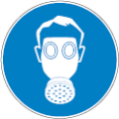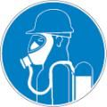
Materials for Protective Clothing: Chemically resistant materials and fabrics. Wear fire/flame resistant/retardant clothing.
Hand Protection: Wear protective gloves. If material is cold, wear thermally resistant protective gloves.
Eye and Face Protection: Chemical safety goggles.
Skin and Body Protection: Wear suitable protective clothing.
Respiratory Protection: Use a NIOSH-approved self-contained breathing apparatus whenever exposure may exceed established Occupational Exposure Limits.
Thermal Hazard Protection: Wear thermally resistant protective clothing.
Other Information: When using, do not eat, drink or smoke.

SECTION 9: PHYSICAL AND CHEMICAL PROPERTIES

9.1. Information on Basic Physical and Chemical Properties
Physical State | : | Gas (Liquid Aerosol)
Appearance | : | Yellow, White, Red Aerosol
Odor | : | Solvent
Odor Threshold | : | Not available
pH | : | Not available
Evaporation Rate | : | Not available
Melting Point | : | Not available
Freezing Point | : | Not available
Boiling Point | : | Not available
Flash Point | : | -18 °C (-0.4 °F) Closed Cup
Auto-ignition Temperature | : | Not available
Decomposition Temperature | : | Not available
Flammability (solid, gas) | : | Not available
Lower Flammable Limit | : | Not available
Upper Flammable Limit | : | Not available
Vapor Pressure | : | Not available
Relative Vapor Density at 20°C | : | Not available
Relative Density | : | Not available
Specific Gravity | : | 1.2 - 1.3 @ 25 °C (77 °F)
Solubility | : | Water: Negligible
Partition Coefficient: N-Octanol/Water | : | Not available
Viscosity | : | 200 cSt (54 KU) (concentrate)
Explosive Properties | : | Contains gas under pressure; may explode if heated
SECTION 10: STABILITY AND REACTIVITY

10.1. Reactivity: Reacts violently with strong oxidizers. Increased risk of fire or explosion.
10.2. Chemical Stability: Contains gas under pressure; may explode if heated. Flammable aerosol. Pressurized container: may burst if heated.
10.3. Possibility of Hazardous Reactions: Hazardous polymerization will not occur.
10.4. Conditions to Avoid: Direct sunlight, extremely high or low temperatures, open flames, sources of ignition and incompatible materials. Direct sunlight, extremely high or low temperatures, heat, hot surfaces, sparks, open flames, incompatible materials, and other ignition sources.
10.5. Incompatible Materials: Strong acids, strong bases, strong oxidizers.
10.6. Hazardous Decomposition Products: None known.
SECTION 11: TOXICOLOGICAL INFORMATION

11.1. Information on Toxicological Effects - Product
Acute Toxicity (Oral): Not classified
Acute Toxicity (Dermal): Not classified
Acute Toxicity (Inhalation): Not classified
LD50 and LC50 Data: Not available
Skin Corrosion/Irritation: Causes skin irritation.
Eye Damage/Irritation: Causes serious eye irritation.
Respiratory or Skin Sensitization: May cause an allergic skin reaction.
Germ Cell Mutagenicity: May cause genetic defects.
Carcinogenicity: May cause cancer.
Specific Target Organ Toxicity (Repeated Exposure): Not classified
Reproductive Toxicity: Suspected of damaging fertility or the unborn child.
Specific Target Organ Toxicity (Repeated Exposure): May cause drowsiness or dizziness.
Aspiration Hazard: Not classified
Symptoms/Injuries After Inhalation: High concentrations may cause central nervous system depression such as dizziness, vomiting, numbness, drowsiness, headache, and similar narcotic symptoms. In elevated concentrations may cause asphyxiation, central nervous system effects, and increased breathing rate. Symptoms of asphyxiation include headache, dizziness, rapid breathing, increased pulse, mood changes, tremors, cyanosis, muscular weakness, narcosis, numbness of the extremities, unconsciousness and death.
Symptoms/Injuries After Skin Contact: Contact with gas escaping the container can cause frostbite and freeze burns. Redness, pain, swelling, itching, burning, dryness, and dermatitis. May cause an allergic skin reaction.
Symptoms/Injuries After Eye Contact: Contact causes severe irritation with redness and swelling of the conjunctiva. . Contact with gas escaping the container can cause frostbite, freeze burns, and permanent eye damage.
Symptoms/Injuries After Ingestion: Not considered a potential route of exposure, but contact with gas escaping the container can cause freeze burns and frostbite.
Chronic Symptoms: May cause cancer. May cause genetic defects. Suspected of damaging fertility or the unborn child.
11.2. Information on Toxicological Effects - Ingredient(s)
LD50 and LC50 Data:
Acetone (67-64-1)
LD50 Oral Rat | 5800 mg/kg
LD50 Dermal Rabbit | 15688 mg/kg
LC50 Inhalation Rat | 44 g/m³

Titanium dioxide (13463-67-7)
LD50 Oral Rat | > 10000 mg/kg

Silica, amorphous (7631-86-9)
LD50 Oral Rat | 7900 mg/kg
LD50 Dermal Rabbit | > 2000 mg/kg

Chlorinated paraffin waxes and hydrocarbon waxes (63449-39-8)
LD50 Oral Rat | > 21500 µl/kg

Hexanoic acid, 2-ethyl-, cobalt(2+) salt (2:1) (136-52-7)
LD50 Oral Rat | 1.22 g/kg
LD50 Dermal Rabbit | > 5000 mg/kg
LC50 Inhalation Rat | > 10 mg/l (Exposure time: 1 h)

Naphtha, petroleum, hydrotreated heavy (64742-48-9)
LD50 Oral Rat | > 6000 mg/kg
LD50 Dermal Rabbit | > 3160 mg/kg
LC50 Inhalation Rat | > 8500 mg/m³ (Exposure time: 4 h)

Propylene glycol monomethyl ether (107-98-2)
LD50 Oral Rat | 5000 mg/kg
LD50 Dermal Rabbit | 13 g/kg
LC50 Inhalation Rat | 27.3 mg/l/4h
LC50 Inhalation Rat | > 7559 ppm (Exposure time: 6 h)

2-Butanone, oxime (96-29-7)
LD50 Oral Rat | 2326 mg/kg (Species: Sprague-Dawley)
LD50 Dermal Rabbit | > 1000 mg/kg
LC50 Inhalation Rat | > 4800 mg/m³ (Exposure time: 4 h)
ATE CA (dermal) | 1,100.00 mg/kg body weight

Propane (74-98-6)
LC50 Inhalation Rat | > 800000 ppm (Exposure time: 15 min)

Isobutane (75-28-5)
LC50 Inhalation Rat | 658 mg/l/4h
LC50 Inhalation Rat | 11000 ppm

Naphtha, petroleum, hydrotreated light (64742-49-0)
LD50 Oral Rat | > 5000 mg/kg
LD50 Dermal Rabbit | > 3160 mg/kg
LC50 Inhalation Rat | 73680 ppm/4h

Ethylbenzene (100-41-4)
LD50 Oral Rat | 3500 mg/kg
LD50 Dermal Rabbit | 15400 mg/kg
LC50 Inhalation Rat | 17.2 mg/l/4h (Exposure time: 4 h)

Xylenes (o-, m-, p- isomers) (1330-20-7)
LD50 Oral Rat | > 5000 mg/kg
ATE CA (dermal) | 1,100.00 mg/kg body weight
ATE CA (vapors) | 11.00 mg/l/4h

Petroleum distillates, hydrotreated light (64742-47-8)†
LD50 Oral Rat | > 5000 mg/kg
LD50 Dermal Rabbit | > 2000 mg/kg
LC50 Inhalation Rat | > 5.3 mg/l/4h

Quartz (14808-60-7)
LD50 Oral Rat | > 5000 mg/kg
LD50 Dermal Rat | > 5000 mg/kg

Titanium dioxide (13463-67-7)
IARC Group | 2B
OSHA Hazard Communication Carcinogen List | In OSHA Hazard Communication Carcinogen list.

Silica, amorphous (7631-86-9)
IARC Group | 3

Chlorinated paraffin waxes and hydrocarbon waxes (63449-39-8)
IARC Group | 2B
OSHA Hazard Communication Carcinogen List | In OSHA Hazard Communication Carcinogen list.

Ethylbenzene (100-41-4)
IARC Group | 2B
National Toxicology Program (NTP) Status | Evidence of Carcinogenicity.
OSHA Hazard Communication Carcinogen List | In OSHA Hazard Communication Carcinogen list.

Xylenes (o-, m-, p- isomers) (1330-20-7)
IARC Group | 3

Quartz (14808-60-7)
IARC Group | 1
National Toxicology Program (NTP) Status | Known Human Carcinogens.
OSHA Hazard Communication Carcinogen List | In OSHA Hazard Communication Carcinogen list.

SECTION 12: ECOLOGICAL INFORMATION

12.1. Toxicity
Ecology - General: Harmful to aquatic life with long lasting effects.

Acetone (67-64-1)
LC50 Fish 1 | 4144.846 mg/l (Exposure time: 96 h - Species: Oncorhynchus mykiss)
EC50 Daphnia 1 | 1679.66 mg/l (Exposure time: 48 h - Species: Daphnia magna [Static])
LC50 Fish 2 | 6210 (6210 - 8120) mg/l (Exposure time: 96 h - Species: Pimephales promelas [static])
EC50 Daphnia 2 | 12600 (12600 - 12700) mg/l (Exposure time: 48 h - Species: Daphnia magna)

Silica, amorphous (7631-86-9)
LC50 Fish 1 | 5000 mg/l (Exposure time: 96 h - Species: Brachydanio rerio [static])
EC50 Daphnia 1 | 7600 mg/l (Exposure time: 48 h - Species: Ceriodaphnia dubia)

Chlorinated paraffin waxes and hydrocarbon waxes (63449-39-8)
LC50 Fish 1 | > 300 mg/l (Exposure time: 96 h - Species: Lepomis macrochirus [static])
LC50 Fish 2 | > 0.0109 mg/l (Exposure time: 96 h - Species: Oncorhynchus mykiss [flow-through])

Naphtha, petroleum, hydrotreated heavy (64742-48-9)
LC50 Fish 1 | 2200 mg/l (Exposure time: 96 h - Species: Pimephales promelas)

Propylene glycol monomethyl ether (107-98-2)
LC50 Fish 1 | 20.8 g/l (Exposure time: 96 h - Species: Pimephales promelas [static])
EC50 Daphnia 1 | 23300 mg/l (Exposure time: 48 h - Species: Daphnia magna)

2-Butanone, oxime (96-29-7)
LC50 Fish 1 | 777 - 914 mg/l (Exposure time: 96 h - Species: Pimephales promelas [flow-through])
EC50 Daphnia 1 | 750 mg/l (Exposure time: 48 h - Species: Daphnia magna)
LC50 Fish 2 | 760 mg/l (Exposure time: 96 h - Species: Poecilia reticulata [static])
ErC50 (algae) | 16 mg/l
NOEC chronic algae | 2.6 mg/l

Naphtha, petroleum, hydrotreated light (64742-49-0)
LC50 Fish 1 | 8.2 mg/l (Exposure time: 96 h - Species: PimephaJes promelas [static])

Ethylbenzene (100-41-4)
LC50 Fish 1 | 11.0 - 18.0 mg/l (Exposure time: 96 h - Species: Oncorhynchus mykiss [static])
EC50 Daphnia 1 | 1.8 - 2.4 mg/l (Exposure time: 48 h - Species: Daphnia magna)
LC50 Fish 2 | 4.2 mg/l (Exposure time: 96 h - Species: Oncorhynchus mykiss [semi-static])
NOEC chronic crustacea | 0.956 mg/l

Xylenes (o-, m-, p- isomers) (1330-20-7)
LC50 Fish 1 | 3.3 mg/l
EC50 Daphnia 1 | 3.82 mg/l (Exposure time: 48 h - Species: water flea)
LC50 Fish 2 | 2.661 (2.661 - 4.093) mg/l (Exposure time: 96 h - Species: Oncorhynchus mykiss [static])
NOEC chronic crustacea | 1.17

Petroleum distillates, hydrotreated light (64742-47-8)†
LC50 Fish 1 | 45 mg/l (Exposure time: 96 h - Species: Pimephales promelas [flow-through])
LC50 Fish 2 | 2.2 mg/l (Exposure time: 96 h - Species: Lepomis macrochirus [static])

12.2. Persistence and Degradability
Nelson Aerosol – Wet Rock
Persistence and Degradability | May cause long-term adverse effects in the environment.

Acetone (67-64-1)
Persistence and Degradability | Readily biodegradable in water.

12.3. Bioaccumulative Potential
Nelson Aerosol – Wet Rock
Bioaccumulative Potential | Not established.

Acetone (67-64-1)
BCF Fish 1 | 0.69
Log Pow | -0.24
Log Kow | -0.24

Silica, amorphous (7631-86-9)
BCF Fish 1 | (no bioaccumulation expected)

Chlorinated paraffin waxes and hydrocarbon waxes (63449-39-8)
Log Pow | > 6

Propylene glycol monomethyl ether (107-98-2)
BCF Fish 1 | < 2
Log Pow | -0.437

2-Butanone, oxime (96-29-7)
BCF Fish 1 | 0.5 - 5.8
Log Pow | 0.65 (at 25 °C)

Petroleum gases, liquefied, sweetened (68476-86-8)
Log Pow | <= 2.8

Propane (74-98-6)
Log Pow | 2.3

Isobutane (75-28-5)
BCF Fish 1 | 1.57 - 1.97
Log Pow | 2.88 (at 20 °C)

Ethylbenzene (100-41-4)
BCF Fish 1 | 15
Log Pow | 3.2

Xylenes (o-, m-, p- isomers) (1330-20-7)
BCF Fish 1 | 0.6 (0.6 - 15)
Log Pow | 2.77 - 3.15

Petroleum distillates, hydrotreated light (64742-47-8)†
BCF Fish 1 | 61 - 159

12.4. Mobility in Soil Not available
12.5. Other Adverse Effects
Other Information: Avoid release to the environment.
SECTION 13: DISPOSAL CONSIDERATIONS
13.1. Waste treatment methods
Waste Disposal Recommendations: Dispose of contents/container in accordance with local, regional, national, territorial, provincial, and international regulations, Do not pierce or burn, even after use.
Additional Information: Empty gas cylinders should be returned to the vendor for recycling or refilling. Do not puncture or incinerate container.
Ecology - Waste Materials: Avoid release to the environment. This material is hazardous to the aquatic environment. Keep out of sewers and waterways.

SECTION 14: TRANSPORT INFORMATION
The shipping description(s) stated herein were prepared in accordance with certain assumptions at the time the SDS was authored, and can vary based on a number of variables that may or may not have been known at the time the SDS was issued.
14.1. In Accordance with DOT
Proper Shipping Name | : | AEROSOLS
Hazard Class | : | 2.1 | 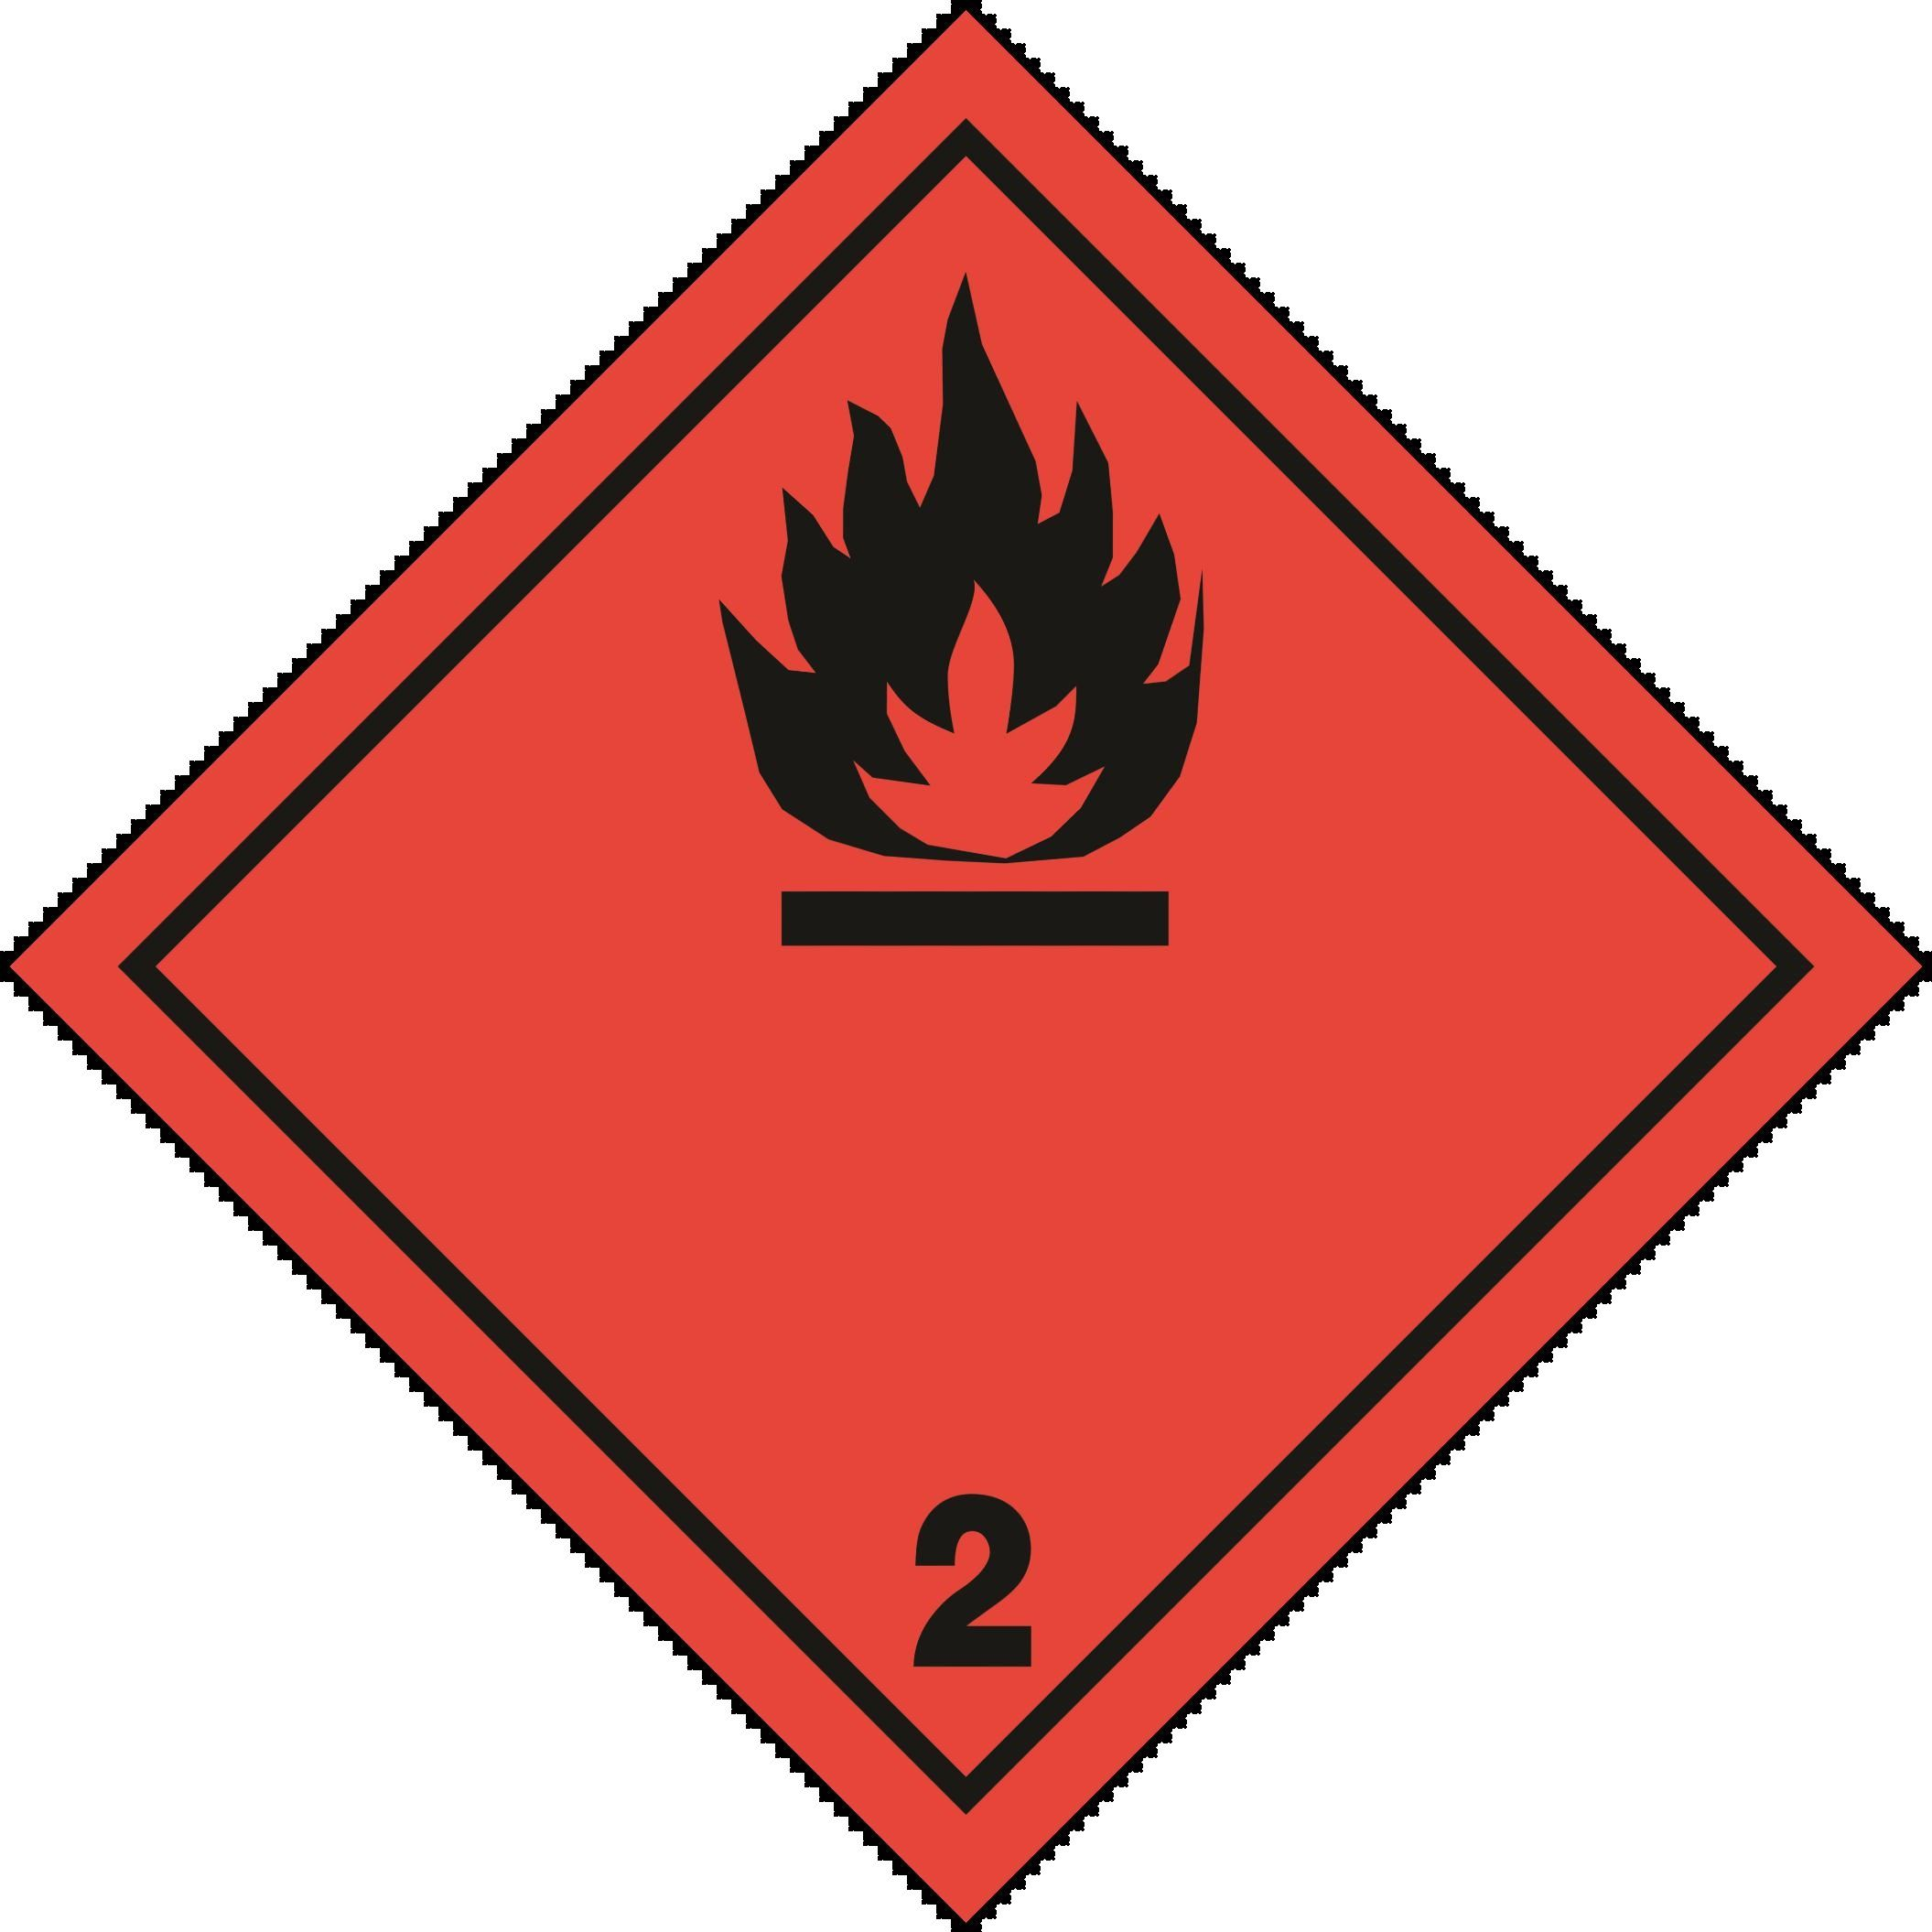
Identification Number | : | UN1950
Label Codes | : | 2.1
ERG Number | : | 126
14.2. In Accordance with IMDG
Proper Shipping Name | : | AEROSOLS
Hazard Class | : | 2.1 | 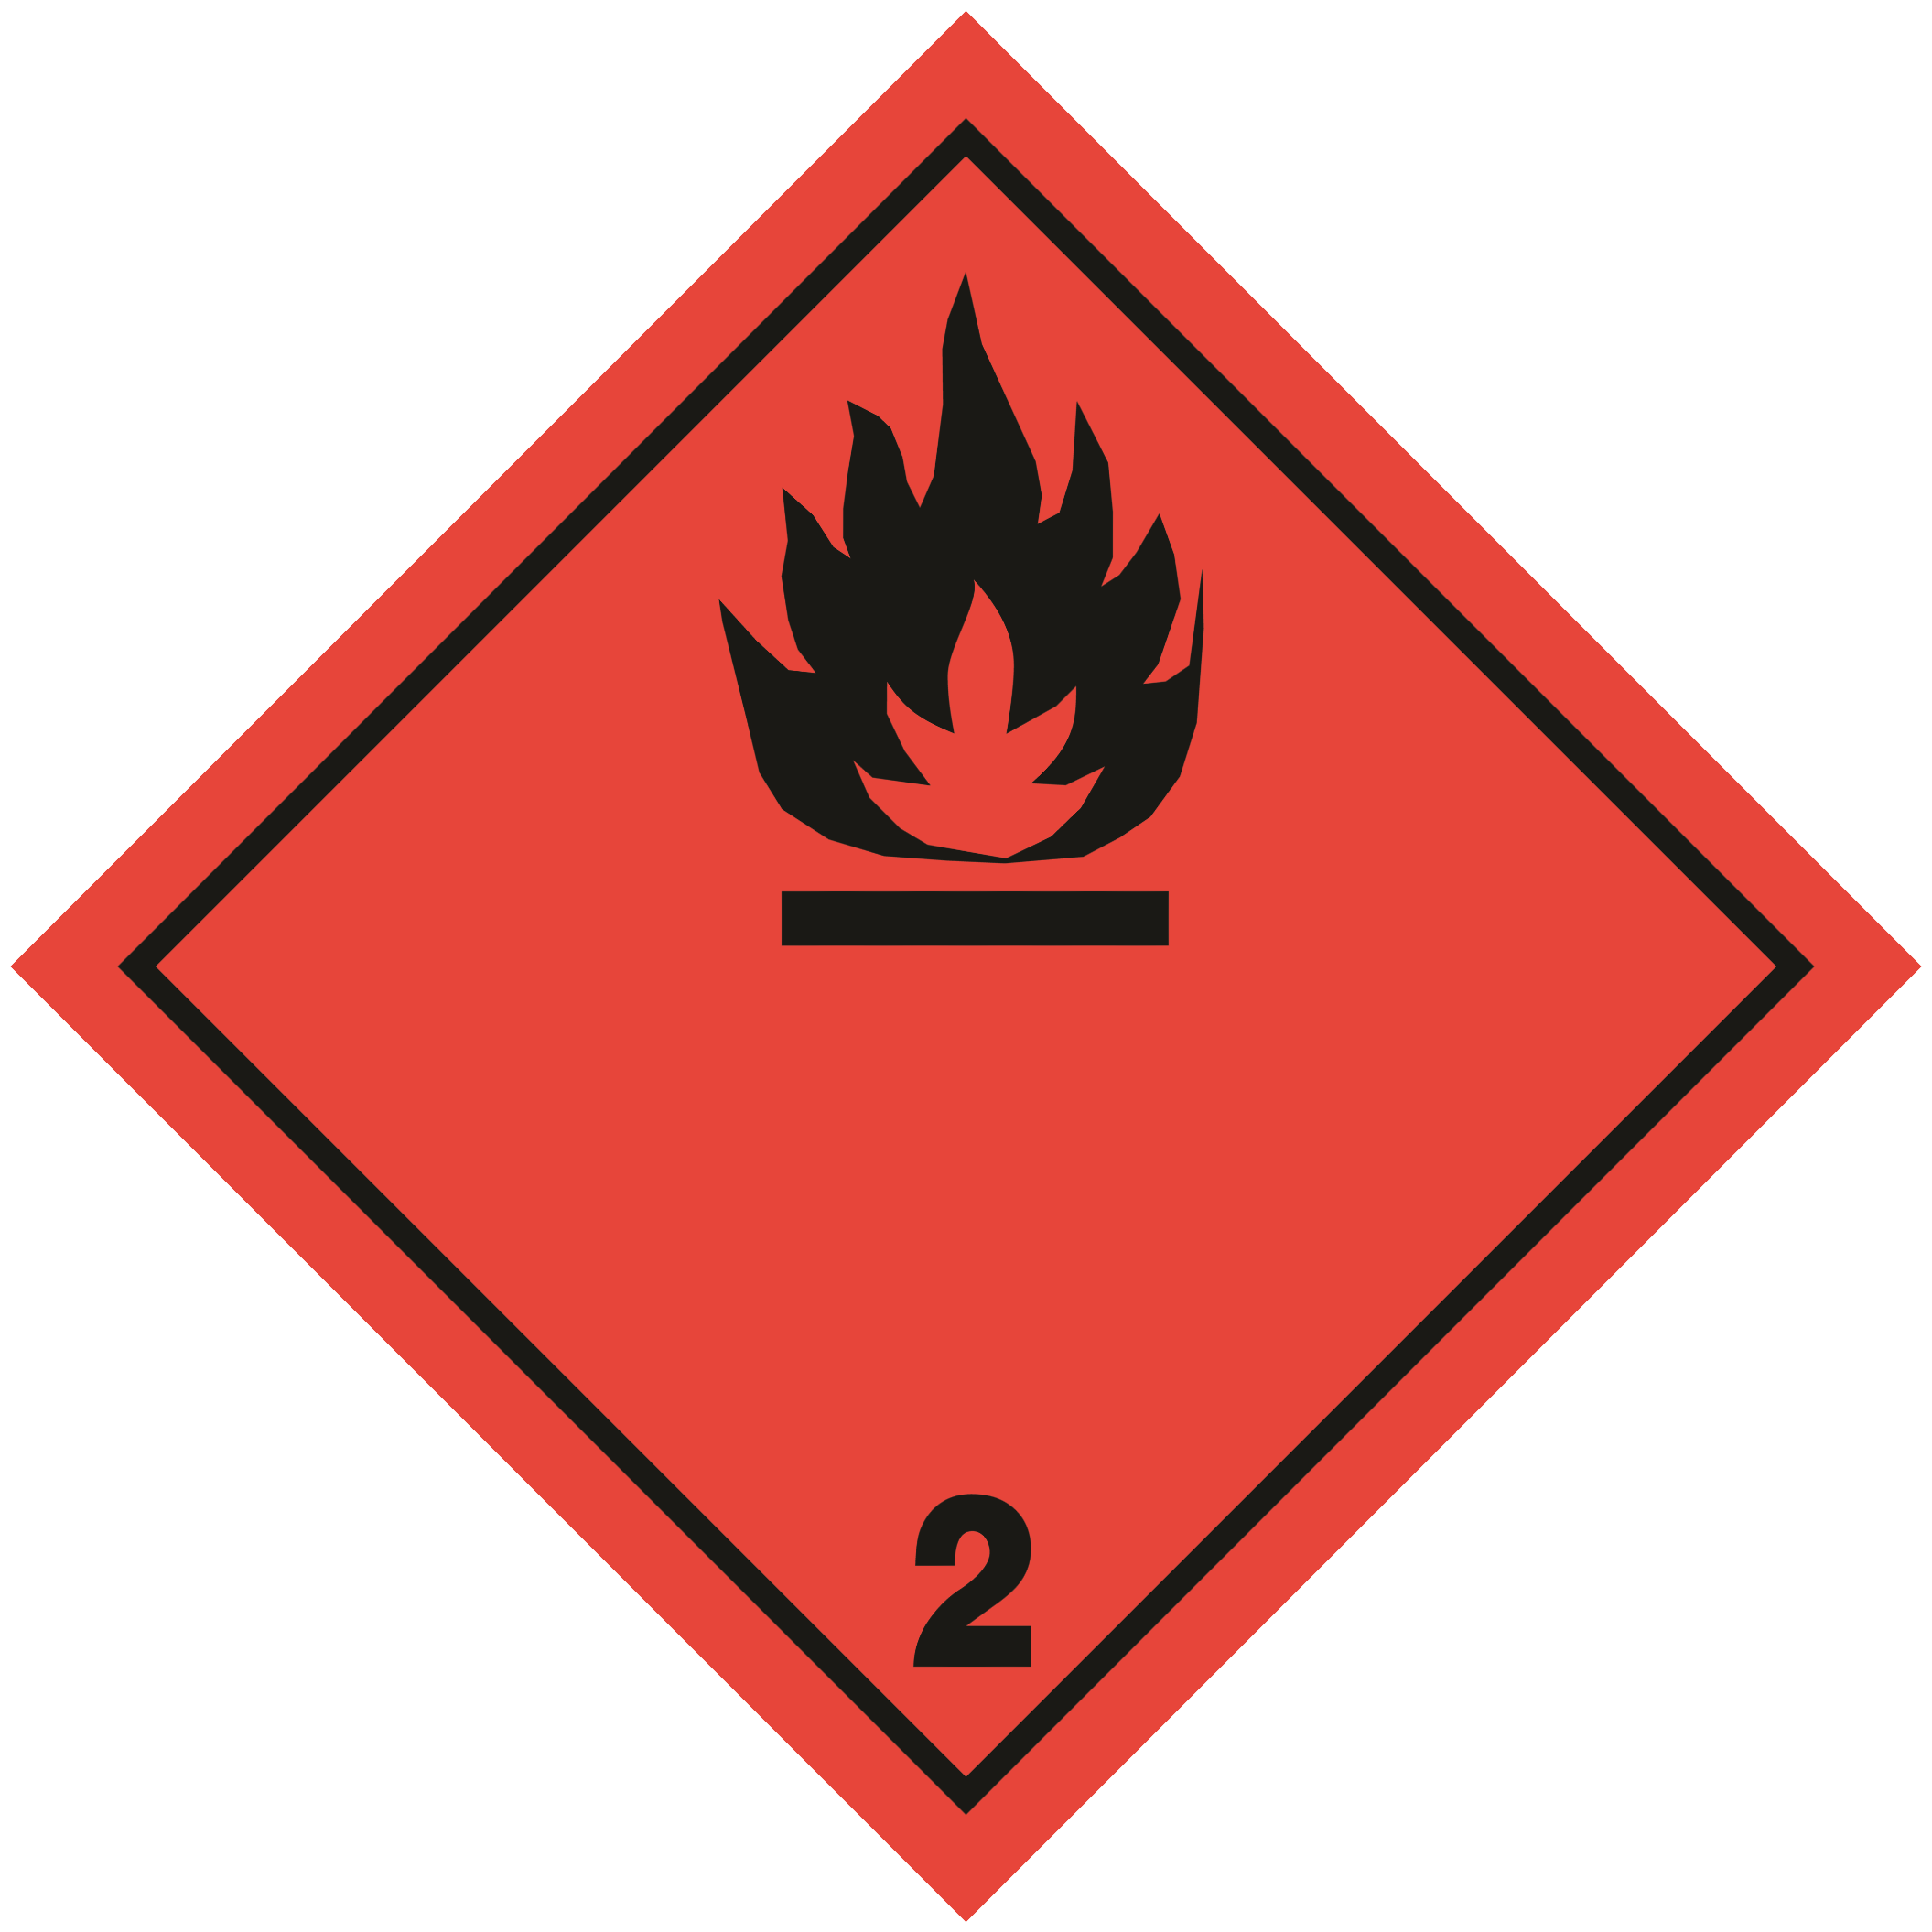
Identification Number | : | UN1950
Label Codes | : | 2.1
EmS-No. (Fire) | : | F-D
EmS-No. (Spillage) | : | S-U
14.3. In Accordance with IATA
Proper Shipping Name | : | AEROSOLS, FLAMMABLE
Hazard Class | : | 2.1
Identification Number | : | UN1950
Label Codes | : | 2.1
ERG Code (IATA) | : | 10L
14.4. In Accordance with TDG
This product is regulated as UN1950, AEROSOLS, Class 2.1. However, as supplied, can be shipped under Limited Quantity Exemption within Canada. Under the TDG, refer to Section 1.17 for additional exemption requirements, if shipping under this exemption.
Proper Shipping Name | : | AEROSOLS
Hazard Class | : | 2.1
Identification Number | : | UN1950
Label Codes | : | 2.1

SECTION 15: REGULATORY INFORMATION

15.3. Canadian Regulations

Acetone (67-64-1)
Listed on the Canadian DSL (Domestic Substances List)
Listed on the Canadian IDL (Ingredient Disclosure List)

Titanium dioxide (13463-67-7)
Listed on the Canadian DSL (Domestic Substances List)

Silica, amorphous (7631-86-9)
Listed on the Canadian DSL (Domestic Substances List)
Listed on the Canadian IDL (Ingredient Disclosure List)

Chlorinated paraffin waxes and hydrocarbon waxes (63449-39-8)
Listed on the Canadian DSL (Domestic Substances List)

Hexanoic acid, 2-ethyl-, cobalt(2+) salt (2:1) (136-52-7)
Listed on the Canadian DSL (Domestic Substances List)

Naphtha, petroleum, hydrotreated heavy (64742-48-9)
Listed on the Canadian DSL (Domestic Substances List)

Zirconium ethyl hexoate (22464-99-9)
Listed on the Canadian DSL (Domestic Substances List)

Propylene glycol monomethyl ether (107-98-2)
Listed on the Canadian DSL (Domestic Substances List)
Listed on the Canadian IDL (Ingredient Disclosure List)

2-Butanone, oxime (96-29-7)
Listed on the Canadian DSL (Domestic Substances List)

Petroleum gases, liquefied, sweetened (68476-86-8)
Listed on the Canadian DSL (Domestic Substances List)

Propane (74-98-6)
Listed on the Canadian DSL (Domestic Substances List)

Isobutane (75-28-5)
Listed on the Canadian DSL (Domestic Substances List)

Naphtha, petroleum, hydrotreated light (64742-49-0)
Listed on the Canadian DSL (Domestic Substances List)

Ethylbenzene (100-41-4)
Listed on the Canadian DSL (Domestic Substances List)
Listed on the Canadian IDL (Ingredient Disclosure List)

Xylenes (o-, m-, p- isomers) (1330-20-7)
Listed on the Canadian DSL (Domestic Substances List)

Petroleum distillates, hydrotreated light (64742-47-8)†
Listed on the Canadian DSL (Domestic Substances List)

Quartz (14808-60-7)
Listed on the Canadian DSL (Domestic Substances List)
Listed on the Canadian IDL (Ingredient Disclosure List)

Limestone (1317-65-3)
Listed on the Canadian NDSL (Non-Domestic Substances List)

SECTION 16: OTHER INFORMATION, INCLUDING DATE OF PREPARATION OR LAST REVISION

Date of Preparation or Latest Revision | : | 01/23/2023
Other Information | : | This document has been prepared in accordance with the SDS requirements of Canada’s Hazardous Products Regulations (HPR) SOR/2015-17.

GHS Full Text Phrases:
------ | Acute Tox. 4 (Dermal) | Acute toxicity (dermal) Category 4
------ | Acute Tox. 4 (Inhalation:vapor) | Acute toxicity (inhalation:vapor) Category 4
------ | Acute Tox. 4 (Oral) | Acute toxicity (oral) Category 4
------ | Aquatic Acute 1 | Hazardous to the aquatic environment - Acute Hazard Category 1
------ | Aquatic Acute 2 | Hazardous to the aquatic environment - Acute Hazard Category 2
------ | Aquatic Acute 3 | Hazardous to the aquatic environment - Acute Hazard Category 3
------ | Aquatic Chronic 2 | Hazardous to the aquatic environment - Chronic Hazard Category 2
------ | Aquatic Chronic 3 | Hazardous to the aquatic environment - Chronic Hazard Category 3
------ | Asp. Tox. 1 | Aspiration hazard Category 1
------ | Carc. 1 | Carcinogenicity, Category 1
------ | Carc. 1A | Carcinogenicity Category 1A
------ | Carc. 1B | Carcinogenicity Category 1B
------ | Carc. 2 | Carcinogenicity Category 2
------ | Eye Dam. 1 | Serious eye damage/eye irritation Category 1
------ | Eye Irrit. 2A | Serious eye damage/eye irritation Category 2A
------ | Flam. Aerosol 1 | Flammable aerosol Category 1
------ | Flam. Gas 1 | Flammable gases Category 1
------ | Flam. Liq. 1 | Flammable liquids Category 1
------ | Flam. Liq. 2 | Flammable liquids Category 2
------ | Flam. Liq. 3 | Flammable liquids Category 3
------ | Flam. Liq. 4 | Flammable liquids Category 4
------ | Muta. 1 | Germ cell mutagenicity, Category 1
------ | Muta. 1B | Germ cell mutagenicity Category 1B
------ | Press. Gas (Comp.) | Gases under pressure Compressed gas
------ | Press. Gas (Liq.) | Gases under pressure Liquefied gas
------ | Repr. 2 | Reproductive toxicity Category 2
------ | Simple Asphy | Simple Asphyxiant
------ | Skin Irrit. 2 | Skin corrosion/irritation Category 2
------ | Skin Sens. 1 | Skin sensitization, Category 1
------ | Skin Sens. 1A | Skin sensitization, category 1A
------ | STOT RE 1 | Specific target organ toxicity (repeated exposure) Category 1
------ | STOT RE 2 | Specific target organ toxicity (repeated exposure) Category 2
------ | STOT SE 3 | Specific target organ toxicity (single exposure) Category 3
------ | H220 | Extremely flammable gas
------ | H222 | Extremely flammable aerosol
------ | H224 | Extremely flammable liquid and vapor
------ | H225 | Highly flammable liquid and vapor
------ | H226 | Flammable liquid and vapor
------ | H227 | Combustible liquid
------ | H280 | Contains gas under pressure; may explode if heated
------ | H302 | Harmful if swallowed
------ | H304 | May be fatal if swallowed and enters airways
------ | H312 | Harmful in contact with skin
------ | H315 | Causes skin irritation
------ | H317 | May cause an allergic skin reaction
------ | H318 | Causes serious eye damage
------ | H319 | Causes serious eye irritation
------ | H332 | Harmful if inhaled
------ | H335 | May cause respiratory irritation
------ | H336 | May cause drowsiness or dizziness
------ | H340 | May cause genetic defects
------ | H350 | May cause cancer
------ | H351 | Suspected of causing cancer
------ | H361 | Suspected of damaging fertility or the unborn child
------ | H372 | Causes damage to organs through prolonged or repeated exposure
------ | H373 | May cause damage to organs through prolonged or repeated exposure
------ | H400 | Very toxic to aquatic life
------ | H401 | Toxic to aquatic life
------ | H402 | Harmful to aquatic life
------ | H411 | Toxic to aquatic life with long lasting effects
------ | H412 | Harmful to aquatic life with long lasting effects

The Nelson paint Company, Inc (TNPC) expressly disclaims all expressed or implied warranties of merchantability and fitness for particular purpose, with respect to the product or information provided herein. All information appearing herein is based upon data obtained from the manufacturer and/or recognized technical sources. While the information is believed to be accurate, TNPC makes no representations as to its accuracy or sufficiency. Conditions of use are beyond TNPC's control and therefore users are responsible to verify this data under their own operating conditions to determine whether the product is suitable for their particular purposes and they assume all risks of their use, handling, and disposal of the product or from the publication or use of, or reliance upon, information contained herein. This information relates only to the product designated herein, and does not relate to its use in combination with any other material or in any other process.

CA GHS SDS

